Cassandra Program 2 :-

Perform the following DB operations using Cassandra.

1.Create a key space by name Library

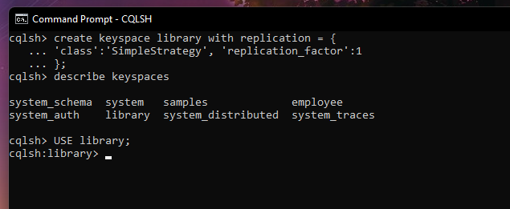

2. Create a column family by name Library-Info with attributes Stud_Id Primary Key,

Counter_value of type Counter,

Stud_Name, Book-Name, Book-Id, Date_of_issue

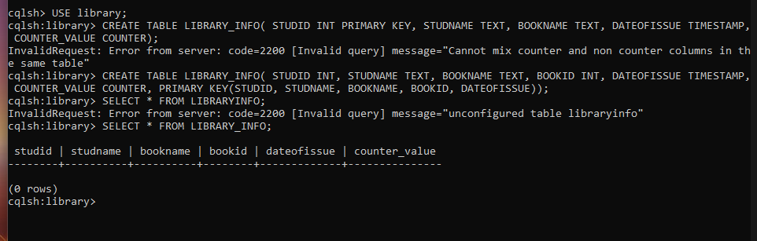

3. Insert the values into the table in batch

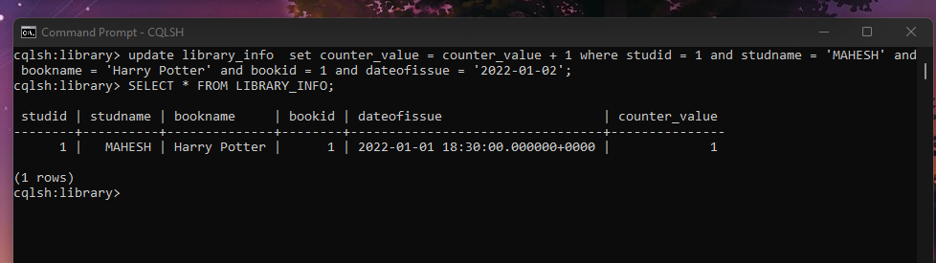

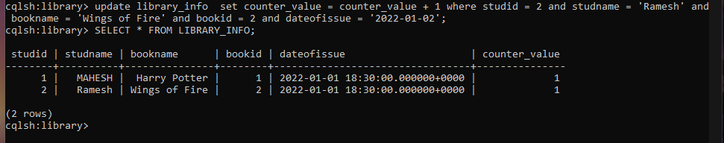

4. Display the details of the table created and increase the value of the counter

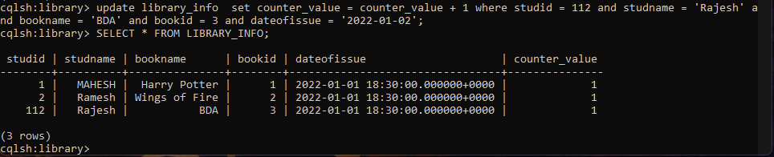

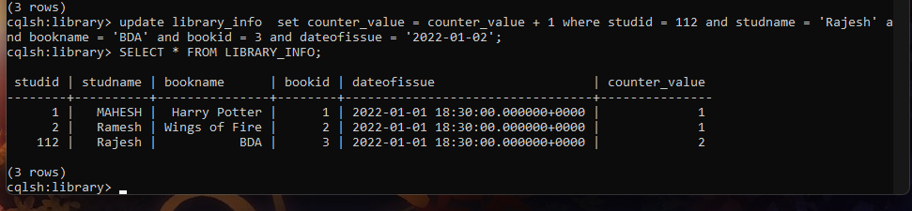

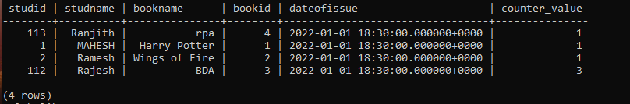

5. Write a query to show that a student with id 112 has taken a book “BDA” 3 times.

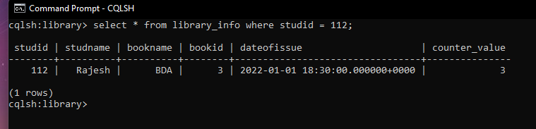

6. Export the created column to a csv file

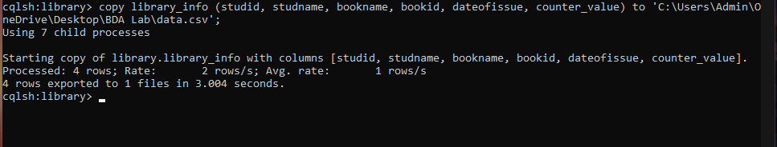

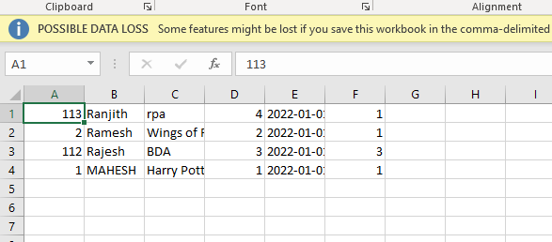

7. Import a given csv dataset from local file system into Cassandra column family

